Year 12 Summer 2016 work

Task 1
Research a designer of your choice (or from the list below) and produce a collection of sheets that highlights their work and their design philosophy. You should make this interesting to look at and informative. You should use multiple mediums to convey your ideas (i.e. photos, sketches, diagrams, written work). The majority of the work should be your own creations and there should be minimal copying and pasting (with the possible exception of photos)
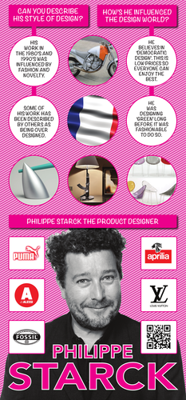
Philippe Starck
Marc Newson
Jonathan Ive
James Dyson
Dieter Rams
Esther Patterson
Emily Pilloton
Ray Eames
Zaha Hadid

An example is on the right.

Task 2
Find at least 3 items that can go on the ‘cool wall’ at BHS. Print out as good quality image of this product to give to Mrs Colley on the first day there.

Task 3
Watch the videos below and then write a report on your opinions of the following subject;

Is design important? What is its purpose?

You should aim to write at least 1500 words (about 2.5 A4 sides)

https://youtu.be/e52fYCYiPok
https://youtu.be/NkQXUKQYrsQ?list=PL6aq1PBlrtR4uh3T-RWwRwfcizGyBd68h
https://youtu.be/hNboCSpEiIU?list=PL6aq1PBlrtR4uh3T-RWwRwfcizGyBd68h
https://youtu.be/Q_0z1kvM6ns?list=PL6aq1PBlrtR4uh3T-RWwRwfcizGyBd68h
https://youtu.be/1XM3wW6yKNA?list=PL6aq1PBlrtR4uh3T-RWwRwfcizGyBd68h
https://youtu.be/GOY0DyCoIqg?list=PL6aq1PBlrtR4uh3T-RWwRwfcizGyBd68h

