Preparing for A-level Geography at J6th

The two topics you will be starting in September are:

- Water and Carbon Cycles (at BGS)
- Contemporary Urban Environments (at BHS)

It is likely that you are familiar with some of the concepts covered in each unit. However, it is really important that you commit to studying them at a higher level, and that you build on your existing knowledge.

To get you started, the Geography Departments would like you to read each of the documents provided and take notes using the Cornell method outlined below.

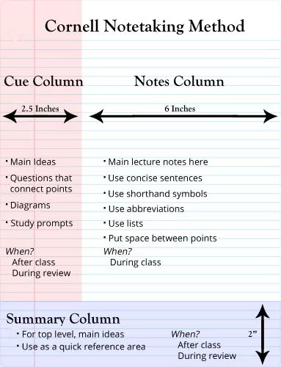
Further guidance on the method can be found by searching the internet with the term “Cornell notes” or via this website: https://pdf.wondershare.com/mobile
-app/cornell-note-taking-system.html

Documents provided:
- Introduction: the carbon cycle
- Cities can seriously damage your health!

Extension
To take your understanding further, explore possible fieldwork enquiries that could be carried out in relation to either of the two topic areas.

We look forward to seeing your notes and fieldwork ideas in September!

