Film Studies
Why you should study Film Studies.
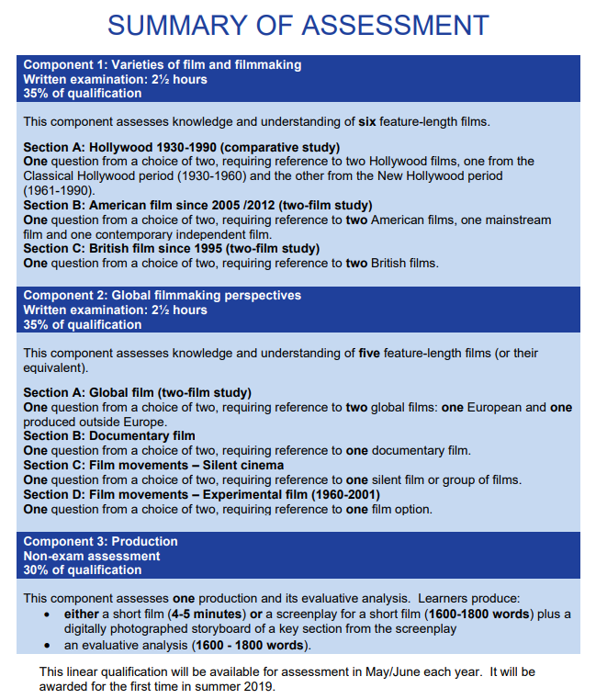

Over the summer it would serve you well to familiarise yourself with the three core study areas and the two additional study areas that will be linked to specific films. What follows is some basic links to reading, viewing and activities that should make you feel more confident and ready for induction in September. Work your way through the links making Cornell notes (video explanation of Cornell notes)(Improving Cornell notes with visuals) and doing activities where and when appropriate. Remember. This is just an introduction to get you thinking and getting ready for all the learning that is to follow. You are not expected to start in September knowing all this material.
In year 12, the core study areas are:
The key elements of film form
Area 1.Cinematography
mise-en-scene
Editing and some editing techniques
Sound design, (Sound match up)
Performance
Area 2: Meaning and response (Including Representation and Aesthetics)
Area 3: The context of film (social, cultural, historical, political and institutional)
The additional study areas are:
- Spectatorship
- Narrative (including critical approaches genre)

After a suitable induction, looking at Key Elements of Film Form we will begin the course by applying the core study areas in relation to:
- Component 1: Varieties of film and filmmaking
  - American film, Section A: Classic Hollywood
    - You might watch some films by Alfred Hitchcock or visit the BFI website to read around the period.
- Component 2: Global Filmmaking Perspectives
  - European Film
    - You might watch some classic European films. Find out more by visiting the BFI website.
- Component 3: Production
  - You’ll have a choice of writing a short screenplay(with storyboard) OR making a short film. This will be followed by a written Evaluative Analysis of your production.
    - You might use the summer break to read some film scripts; learn the codes and conventions (c&c); find some free film script software to try out; watch some free short films online; make a few short films using what you’ve learned about the core areas of study.
I don’t know why, but I’ve always loved this simple site that shows you the basics:
Love this simple site and the suggested reading at the bottom is a good little list to start your wider reading. The Site.

