A Level PE



Summer Transition Work

Beverley Joint 6th Form: Transition Pack

Welcome to the Physical Education Department
We look forward to meeting you and welcoming you to the Sixth Form.
This Transition Pack contains information to support your transition from GCSE to A Level study.
Please read all the documents ready to begin Year 12:
• Independent Learning in Physical Education
• Useful Physical Education Websites
• Non-Exam Assessment (NEA) in Physical Education
• Logbook
• Physical Education Introductory Tasks

- Download the exam board specification which is available here: OCR A Level Physical education

- Read the section called ‘Specification Overview’, focusing on the A Level content

- Download the list of approved practical/coaching activities which is available here: Activity List
You will need to scroll down to the section called 'List of activities applying to qualifications awarded from 2022 for A level as you will receive your A Level grades in 2027. Make sure that the sport that you compete in/coach in is on the list. If it is not on the list, please contact Mrs Owen , Head of Physical Education (email: E.Owen@beverleyhigh.net) or Mr Caddell, Leader of PE (email: s.caddell@beverleygrammar.co.uk)

- Some of the resources in this pack will become more useful when you have moved further through the course, such as the A Level specification, so store them where you can revisit them over the next 2 years.

- Don’t worry if some of the work sounds challenging. A Level work is more difficult than GCSE work after all. Your teachers will be supporting you through this transition. Please talk to us if you are unsure about any aspect of the course.

We look forward to seeing you soon.
Beverley J6th PE Department
Beverley Joint 6th Form: Transition Pack
Physical Education Useful Websites and Podcasts
Here is a selection of websites and podcasts that you should have a look at before starting Physical Education and then refer to throughout your studies.

- https://theeverlearner.com/ is a brilliant hub for videos, quizzes and tests. Once you start the course you will receive log in details, but there are some free resources that you could take a look at to get you started.

- https://www.bbc.co.uk/sportKeep up to date with what is happening in sport. Read the articles and blogs to give you up to date examples.

- https://www.brianmac.co.uk/This is a good website that has lots of information that will help you with your theory lessons.

- https://www.bhf.org.uk/The British Heart foundation has excellent information on lifestyle disease.

- https://believeperform.com/An excellent website for Sports Psychology.

- ‘The Real Science of Sport Podcast’ is an excellent Podcase for Sport Physiology.

- ‘Sports Biomechanics Lecture Series’ is an excellent Podcast for Sports Biomechanics.

Beverley Joint 6th Form: Transition Pack
Non-Exam Assessment (NEA) in Physical Education
As well as completing 3 written papers, students studying Physical Education will also be assessed in a fourth component: Performance in Physical Education. This component makes up 30% of the A Level and is comprised of two sections: Practical Performance and the Evaluation and Analysis of Performance for Improvement (EAPI). Students will be prepared thoroughly for both sections of this component.
Practical Performance
Students will be assessed as either a performer or a coach in one of the activities from the approved list. Only the activities listed are allowed and students must be committed to performing/coaching to a good standard throughout the two years. Please find the approved list of activities in the link below:
- Make sure that you read the correct section. You will receive your A Level grade in 2027, so you should read the 'List of activities applying to qualifications awarded from 2022 for A level. Activity List
- Check that the sport you compete in/coach in is on the list. If it is not on the list, please contact Mrs Owen , Head of Physical Education (email: E.Owen@beverleyhigh.net) or Mr Caddell, Leader of PE (email: s.caddell@beverleygrammar.co.uk)

Students should begin to gather video evidence of their practical performance over the summer break. Students are assessed in their practical performance over two years, so this is especially important if students take part in summer sports, such as Cricket and Athletics, because they will need to be assessed in their performance in both summers (2025 and 2026). Wherever possible, when taking part in competitive performances, students should get a friend, parent/carer or substitute to record them and they should save these videos in a safe place. At the start of Year 12, students will be shown exactly how to edit this material into a format that will be used for their assessment. If you would like any advice please email E.Owen@beverleyhigh.net) or s.caddell@beverleygrammar.co.uk

A log book should be started over the summer* where students should record the date of any competitive performances that they take part in, the level of competition (name of competition, league or cup for example) and the outcome. A blank Participation Log Sheet is provided on the next page for students to use. Keep your log book in a safe place.
* If students are not competing over the summer because they take part in winter sports, they should not worry about completing a log book or making recordings over the summer.

The first deadline in Year 12 for submission of video evidence will be Christmas.

Beverley Joint 6th Form: Transition Pack

OCR A Level Physical Education Competitive Log

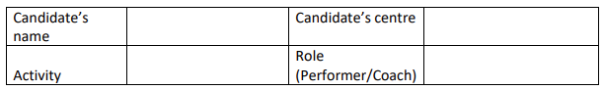
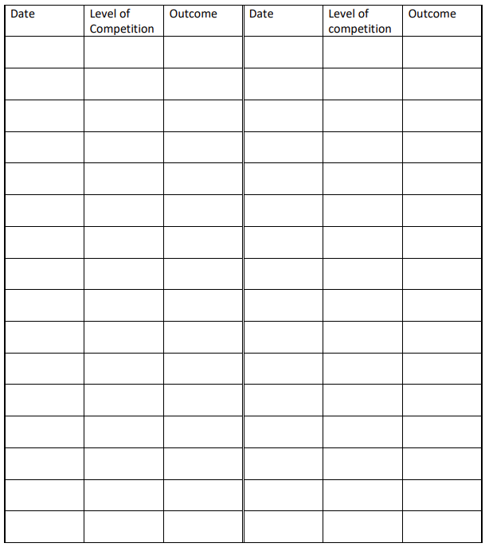
Beverley Joint 6th Form: Transition Pack
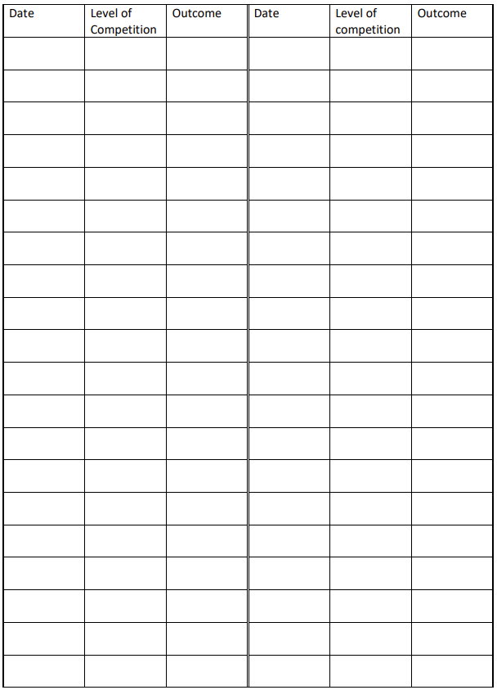

Beverley Joint 6th Form: Transition Pack

PHYSICAL EDUCATION A LEVEL
Content of ‘Physiological Factors Affecting Performance’ (Exam Paper 1)
The component ‘Physiological Factors Affecting Performance’ focuses on developing your knowledge of the science behind physical activity. This includes the structure and function of key systems in the human body and the adaptations that occur in these systems as a result of changes in diet, training and the environment. You will also study sports injury and biomechanics in sport. You will develop your ability to apply your knowledge in a range of sporting scenarios and your ability to critically evaluate.

Introductory Tasks
Applied Anatomy and Physiology
If possible, please print off Task 1 and Task 2 on the next 3 pages (below). Don’t worry if you can’t print off the pages, bring your answers written on lined paper to your first lesson. Remember to complete Task 3 on the final page of this pack too.
Task 1: Answer the following questions on the structure and functions of bones. You may want to start with the following website as reference (but you won’t find all of the answers there!):
https://www.bbc.co.uk/bitesize/guides/zq3sbk7/revision/1
Structure and Function of Bones
Question 1
Briefly outline the five functions of bones in vertebrates
_____________________________________________________________________________________________________________________________________________________________________________________________________________________________________________________________________________________________________________________________________________________________________________________________________________________
Question 2
Name the three kinds of cells which most bones consist of
__________________________________________________________________________________________________________________________________________________________________

Beverley Joint 6th Form: Transition Pack
Question 3
Choose one of these cells and explain its function in bones.
___________________________________________________________________________________________________________________________________________________________________________________________________________________________________________________

Question 4
Complete the labelling of the diagram of long bone anatomy
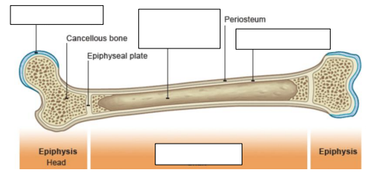
Question 5
Name the four types of bone and state an example of a function they may have in sport
_____________________________________________________________________________________________________________________________________________________________________________________________________________________________________________________________________________________________________________________________________________________________________________________________________________________

Beverley Joint 6th Form: Transition Pack

Structure and Function of Joints
Task 2: Answer the following questions on the structure and functions of joints. You may want to use the following website and others as reference:
https://www.bbc.co.uk/bitesize/guides/zq3sbk7/revision/3

Question 6
Complete the statement:
The three main classifications of joints are synovial joints, _ _ _ _ _ _ _ _ _ _ _ joints and fixed joints.

Question 7
Name three types of synovial joint and give an example of each
___________________________________________________________________________________________________________________________________________________________________________________________________________________________________________________

Question 8
Add all of the necessary labels to the diagram of a synovial joint

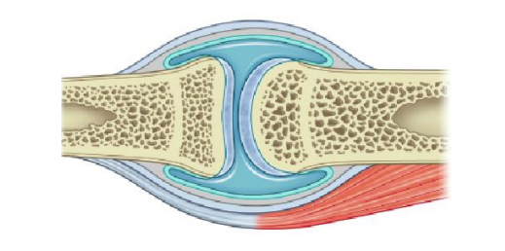

Beverley Joint 6th Form: Transition Pack

Content of ‘Psychological Factors Affecting Performance’ (Exam Paper 2)
This component aims to develop knowledge and understanding of the principles required in order to optimise the learning of new, and the development of existing, skills. You will develop an understanding of the importance of being able to classify skills in order to select the most suitable approach to the learning of motor skills.
This component looks at the underlying factors required for effective and efficient performance. You will also gain a detailed understanding of the impact of the environment and conditions in which new skills are learned on the success of acquiring these motor skills.
Knowledge and understanding will also be developed in the different approaches and theories to teaching new skills as well as the guidance and feedback used to support this. Focus will also be placed on enhancing existing skills and the opportunities to transfer between the two.
Through application of knowledge gained from this topic, you will be able to develop your skills in other sporting roles such as coach or leader, as well as directly relating it to your own performance.

Skills can be classified using a variety of continua. Categories include:
• environmental influence (open/closed)
• pacing (self-paced/externally paced) • muscular involvement (gross/fine)
• continuity (discrete/serial/continuous)
• difficulty (simple/complex)
• organisation (low/high).

Your task is to research and identify key characteristics of the specified continua and state some practical examples:

Environmental influences
This continuum is concerned with the effects of the ........................................ on skills
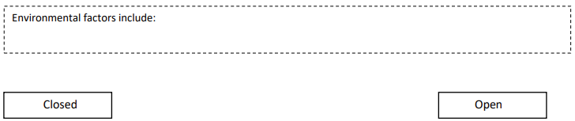
Beverley Joint 6th Form: Transition Pack
Practical examples (Don’t just identify, give 2 reasons why they are an open / closed skill)
- __________________________________________________________________________________________________________________________________________________________________________________________________________________________________________________________________________________________________________________________________________________________________________________________________________________________________________________________________

Pacing
This skill classification focuses on the ................................................................ that the performer has over the timing of the motor skill
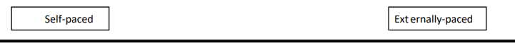
Practical examples
- __________________________________________________________________________________________________________________________________________________________________________________________________________________________________________________________________________________________________________________________________________________________________________________________________________________________________________________________________

Muscular movement
This classification looks at the ....................... of the movement

Practical examples
- __________________________________________________________________________________________________________________________________________________________________________________________________________________________________________________________________________________________________________________________________________________________________________________________________________________________________________________________________

Beverley Joint 6th Form: Transition Pack
Content of ‘Socio-Cultural Issues in Physical Activity and Sport’ (Exam Paper 3)
In this component you will study sport and society and contemporary issues in physical activity and sport. You will develop your knowledge and understanding of how physical activity and sport have developed through time and the factors that shape contemporary sport. You will also gain an understanding of the nature of global sporting events and how they reflect and are impacted upon by social issues.
Watch the video clip London 2012 Olympics (From 13:40-18:40) What does this clip show preindustrial Britain like? What are some of the characteristics?

___________________________________________________________________________________________________________________________________________________________________________________________________________________________________________________________________________________________________________________________________________________________________________________________________________________________________________________________________________________________________________________________________________________________________________________________________________________________________________________________________________________________________________________________________________________________________________________________________________________________________________________________________________________________________________________________

___________________________________________________________________________________________________________________________________________________________________________________________________________________________________________________________________________________________________________________________________________________________________________________________________________________________________________________________________________________________________________________________________________________________________________________________________________________________________________________________________________________________________________________________________________________________________________________________________________________________________________________________________________________________________________________________

Research the sport and pastimes in pre-industrial Britain and complete the table below with the information that you have found out:
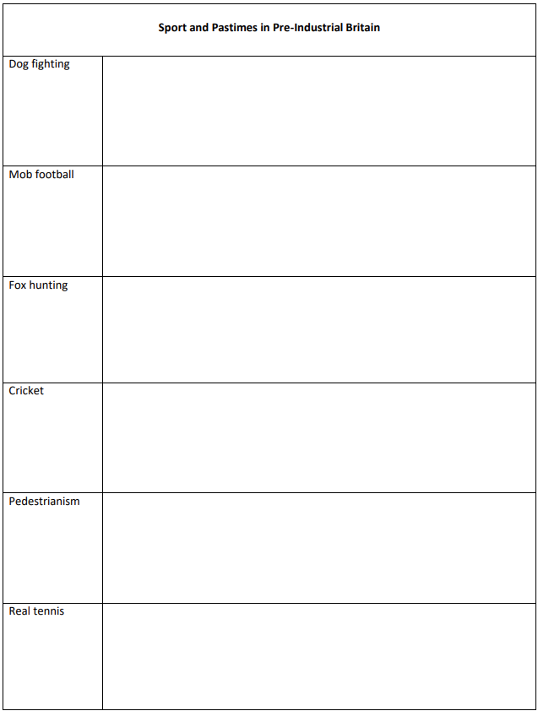

Beverley Joint 6th Form: Transition Pack
Content of Performance in Physical Education (NEA)

This component is NEA (coursework) and is comprised of two sections:
• Practical Performance
• Evaluation and Analysis of Performance for Improvement (EAPI)
Practical Performance
In order to be assessed in this component of the A Level, you must be competing regularly or acting as a coach in one of the activities on the list throughout the two years of A Level. The approved list can be accessed here if you have not already done so. It is essential that you check that you will be able to be assessed practically, so read the section called 'List of activities applying to qualifications awarded from 2022 for A level. You will receive your A Level grades in 2027 Activity List You will submit video evidence over the A Level course which will be assessed, and you will be given a practical or coaching mark based on this.
Evaluation and Analysis of Performance for Improvement
For this task you will watch a performer competing in an activity of your choice from the approved list. You will assess the players strengths and weaknesses, highlighting a major skill weakness. You will go on to create an 8-week development plan which would help them to improve in this skill weakness. This is an oral task, so there is no writing. Instead, you say your answer out loud. This task is often referred to as ‘EAPI’
Introductory Task
Task: Complete this task and bring it to your first PE lesson
Skills in your sport
1. List all of the skills that you can think of in your sport.
2. Now rank them by placing a number next to each one. Number the most important skill as 1, and so on. 3. You may wish to go into extra detail by thinking of the ranking for different positions, if this is applicable in your sport.
4. Choose 1 skill and try to write in words what a player needs to do in order to execute this skill effectively. Try to write about what they need to do with each part of their body.
5. Watch some videos online, ideally of amateurs (for example, type ‘U16’ as your search term followed by the name of your sport, then select ‘videos’). Try to highlight players that you think are performing this skill well and ones who don’t play the skill well. Try to pick out exactly what the players who perform it incorrectly are doing wrong. For example, is it their timing? Is it their head position? Or are they not strong enough? Is there a particular aspect of this skill that players tend to get wrong? Make notes on what you see.
6. Draw out 6 drills that would help a player improve in this skill specifically.
7. You may wish to repeat this for a number of skills in your sport

