Year 12 A-level Textiles Summer Preparation
Welcome to Textile Art A-level!!
Over the summer you will prepare for your first project and make sure that you have some basic resources for the course. The first project is based on “Natural Forms”, you will be focussing mainly on line, shape and pattern and exploring some really contemporary and experimental techniques! “Natural Forms” will be a black and white project, so that colour does not distract from the lines, shapes and patterns. This year, we will look at the natural form patterns 2020 S/S RTW Alexander McQueen collection as inspiration, because these have a modern, sketch-like quality. Other practitioners, designers and artists will be used, too. Colour projects come afterwards, so if you love colour, you will be happy! The first part of this project will be exploring natural forms, exploring ways of recording the forms and developing unusual ways of using natural forms for this contemporary look.
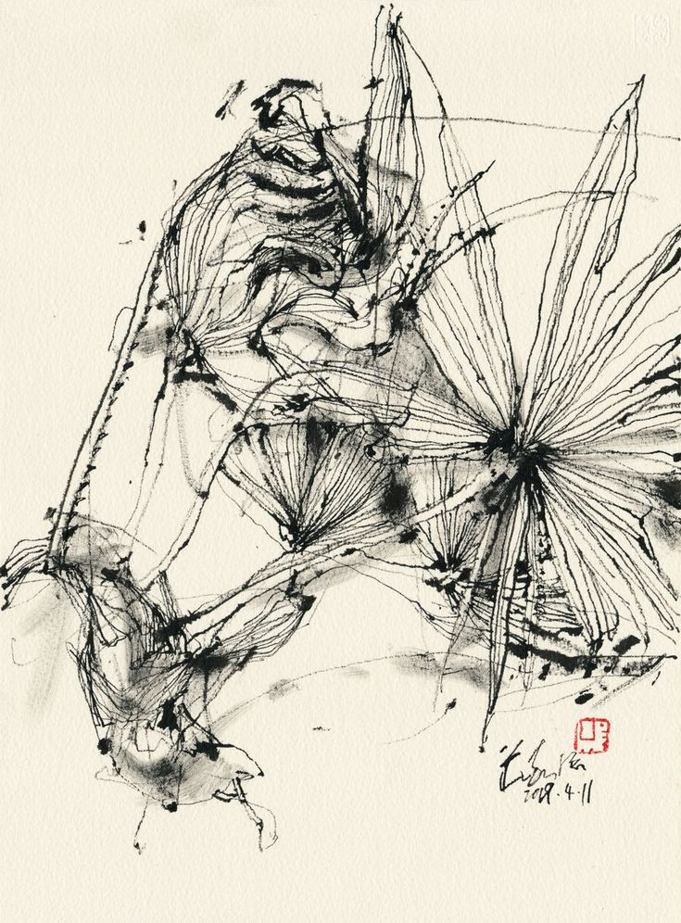
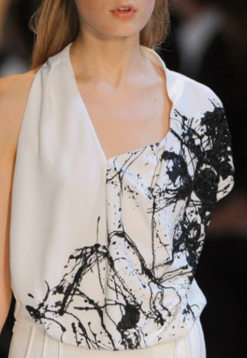
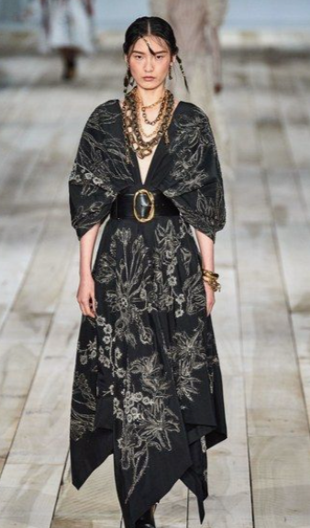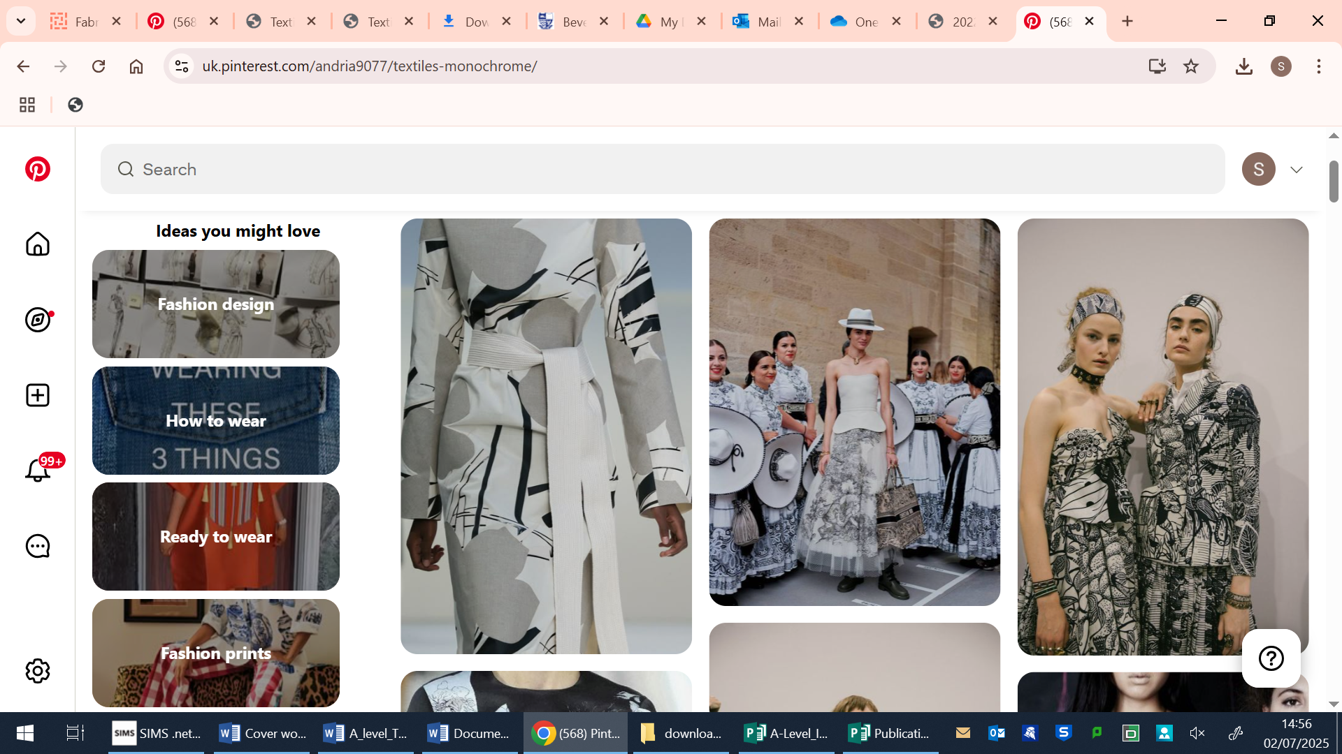
Task 1: Prepare for “Natural Forms”
Objective: to have 10 or more research photos and 4 or more sketches, as practice.
Successful projects are based on subject matter you can readily get hold of to draw or take photos of. The drawings and photos will inform the shapes, lines & textures in your textile artwork for your first project. Creating a repeat pattern, using unusual tools and media, exploring lines on a large scale are aspects you will be exploring during this project.
- So, with this in mind, collect research photographs: Nature: Leaves, fungus, trees, plants, water ripples, etc.
TIP: You gain marks for creating a “personal response” and developing a “concept”. There is no rush, as this is usually developed after a few weeks, but it does help if your theme has a personal link (e.g. the woods you played in as a child), or a strong concept (e.g. the impact of pollution on the sea). Bear in mind you will need to take about 30 photos to get 10 useable ones. Print these off postcard-size or larger.
2. The 4 (or more!) sketches need to be made directly from the objects (don’t draw the photos) you will need 4, A4 or bigger. These can be line drawings, or shaded. Please so not use pencil, try biro, felt-tip, etc. instead – be brave!
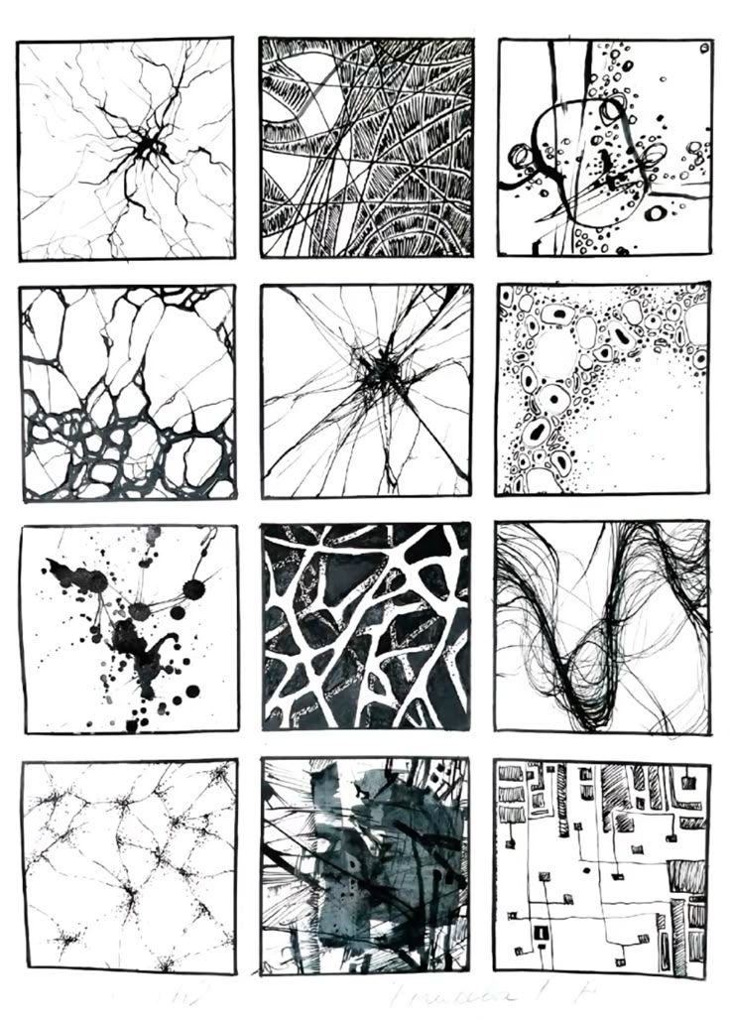
3. Go on to Pinterest, find “Miss Hurst” and follow. There is a board named “Textiles Monochrome” – please follow that board, as this will be a great resource and give you a good idea of what the project will be about.

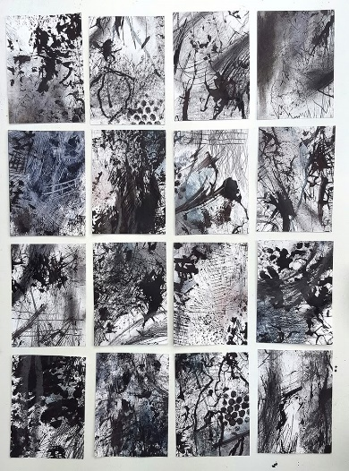

Task 2 Prepare for the course:
A: Equipment
At the start of the course, you will have the opportunity to buy some of the tools and materials from school, so please do not buy lots of expensive sewing equipment for home.
Recommended for the start of the course:
Drawing equipment: Biro, (fine-liners will be in the resources pack from school), pencils are not necessary.
Something to keep your drawing equipment in (a tin is recommended, as the lid can be used as a palette)
A tool box/fishing box to keep your own sewing kit in (you could personalise it, too!)
A sewing machine is not necessary, but very useful. If you do intend to buy a sewing machine, our advice is: keep it basic. You will only ever need to go forwards, backwards & drop the “feed-dog teeth” so you can embroider.

B: Resources: Collect “stuff”
Objective: to have your own unique resources to hand.
Become a bit of a hoarder, if you are not already! Save fabric scraps, bits of ribbon, interesting papers and other bits you find interesting. Good places to start are envelopes, tickets, flyers, packaging, etc.
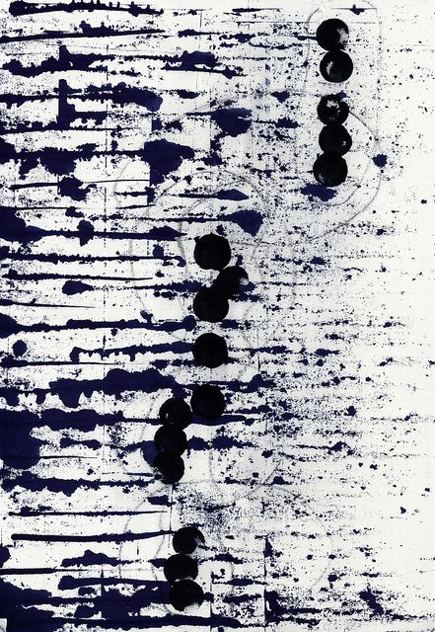
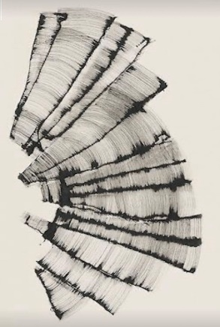
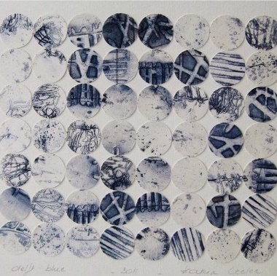
Your artwork will be personal to you, so keep things that you like. You should do this throughout the whole A-level course, at least for each project. At first, you may choose to collect items that fit the topic & colour scheme for each project. There is no need to buy anything, look for items being thrown away, as suggested above.

Task 3: See art and get inspiration, if you can.
Objective: to view art, improve understanding of art and to see art in real life rather than in a book or on the net.
You will be producing textile art during the course, but you will get inspiration from a variety of sources including; fine art, sculpture, photography, ceramics, fashion and 3D design.
In most towns and cities there is some sort of art to look at. This could be:
- An art gallery
- A museum
- A church or place of worship
- Street art
- Memorial sculptures
There are art galleries dotted around, so look out for them when you are in a new city, or on holiday.
Costumes in films are an excellent way to find inspiration and can often influence fashion on the High Street. Be aware of the costumes in films as you watch them. The more creative information you see, the better your own creativity will be – so keep looking where you can.

Task 4: Textiles Practice
Objective: practice your textile skills.
A: Create 3 or more detailed textile samples.
Layer a variety of techniques on each. They will be approximately A4 size. Use the visual images from Task 1 to inspire your shapes & lines. Keep things black, white and grey, if you can. You can use any techniques you know already: appliqué, reverse appliqué, 3D appliqué, embroidery, couching, yo-yos, ruffles, etc.
The following artists could inspire you:
- Jo Horswill: Paperclothstudio
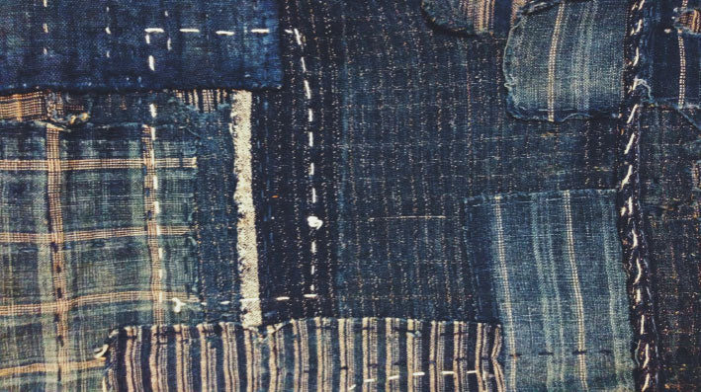
- Elizabeth Bunsen
- Cas Holmes
- Tilleke Schwarz
- Also: Japanese boro technique

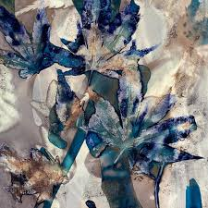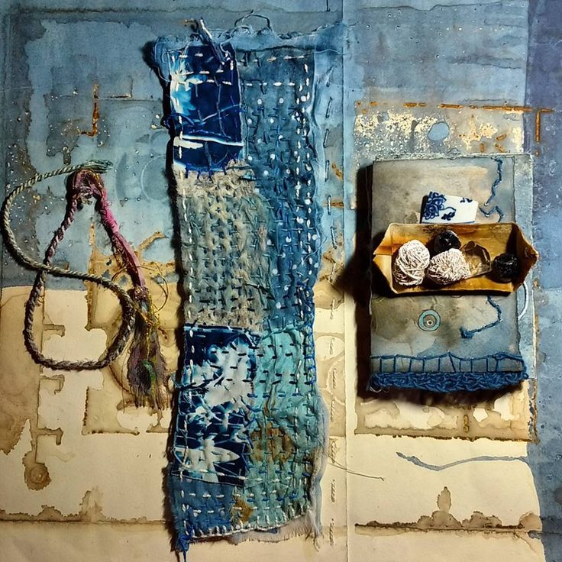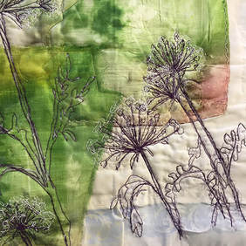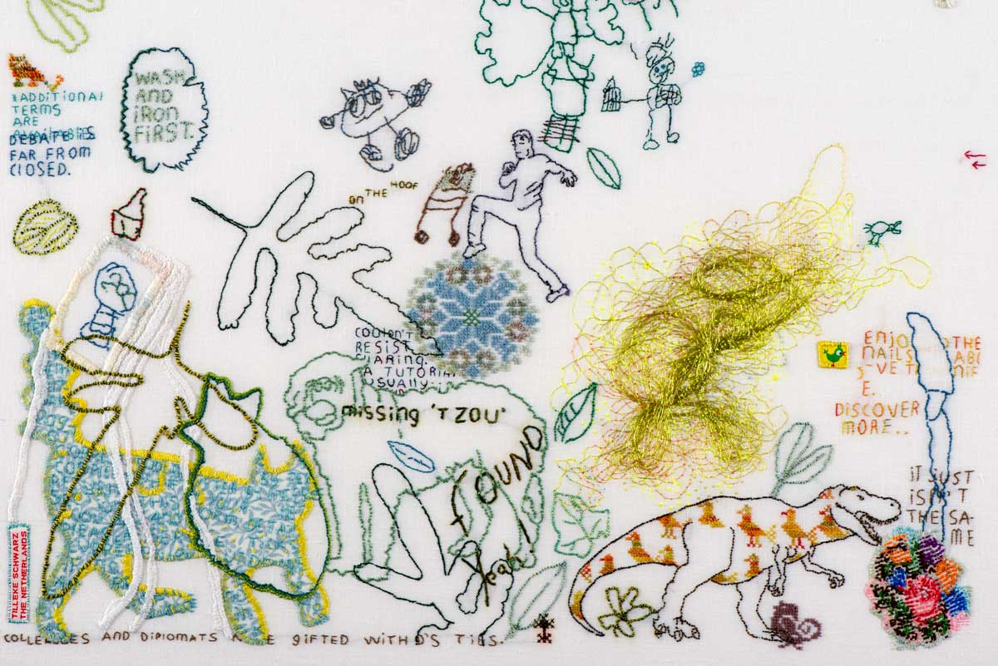

Hand-in:
When you come to your first lesson back after summer, you should have with you:
- 10 or more photos of your topic
- 4 or more drawings A4 size
- 3 or more textile samples A4 size
Please do not stick these down, keep them loose.

Useful information (exam board is AQA)
Each unit you produce will be marked on the following:
Assessment Objective 1: Research: 25%
Assessment Objective 2: Experimentation with textile techniques: 25%
Assessment Objective 3: Recording Ideas: 25%
Assessment Objective 4: Personal Response: 25%

The summer preparation is mainly research, but does contribute to the other Assessment Objectives.
Other things you can do: non-compulsory extension task
Look at textile artists.
Look at textile artists online, in books or in galleries. You could look at the following:
https://www.textileartist.org/
www.62Group.org.uk
www.textilearts.net
Don’t just look at Pinterest or Google.
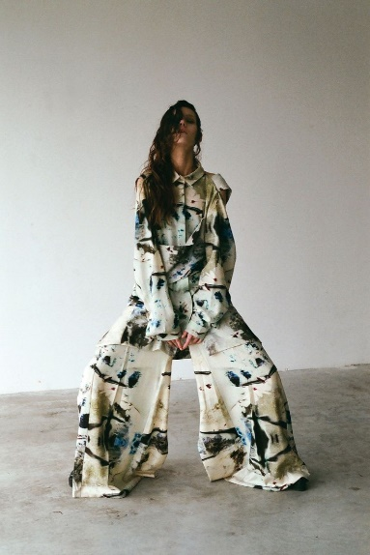
Looking at non-textile art & looking at artists’ blogs will also help.
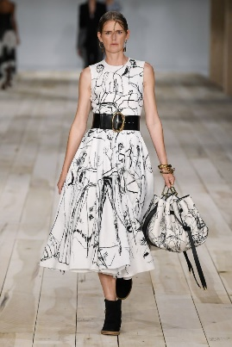
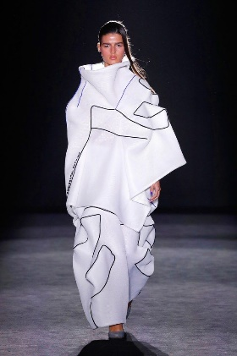
The more you experience, the better your work will be!


