AQA A Level Theatre Studies
Summer Work
BHS
Name:

Our first unit in Theatre Studies is looking at devising Drama. In doing so, we need to explore a range of Theatre styles and practitioners in depth. To prepare for the course, there are some attached reading pieces with accompanying tasks to help build up your understanding of the first few practitioners.
Please bring the completed booklet/additional sheets to our first session in September.

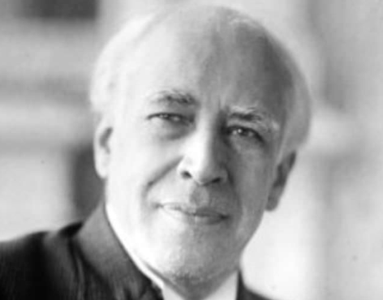

Konstantin Stanislavski and His Acting System

Who Was Stanislavski?
Konstantin Stanislavski was a Russian actor, director and theatre practitioner whose ideas transformed modern acting. Before his work, actors often relied on exaggerated gestures, theatrical poses and declamatory speech. Stanislavski believed that actors should create believable human behaviour on stage so that audiences feel they are watching real people rather than performers.
He co-founded the Moscow Art Theatre in 1898, where he developed many of his ideas through rehearsals and productions. His methods later influenced acting techniques across Europe and America, including the development of Method Acting.
Stanislavski did not create a fixed set of rules. Instead, he developed a system of training and rehearsal techniques designed to help actors perform truthfully under imaginary circumstances.

The Aim of the Stanislavski System
Stanislavski asked a simple but important question:
How can an actor behave truthfully in fictional circumstances?
He believed actors should not merely imitate emotions. Instead, they should understand the character's thoughts, desires and objectives. The actor's task is to experience the role sincerely while remaining technically in control.
His famous phrase was:
"Love the art in yourself, not yourself in the art."
This emphasises discipline, dedication and ensemble work rather than individual ego.

The Given Circumstances
The given circumstances are all the facts provided by the play.
These include:
- The historical period.
- The location.
- Relationships between characters.
- Social class.
- Events that have happened before the play begins.
- The immediate situation of a scene.
Actors must investigate these details because they shape how a character behaves.
For example, if a character is speaking during wartime, is poor, and has just received bad news, these circumstances affect movement, speech and decisions.

The Magic If
Stanislavski developed the Magic If:
"What would I do if I were in this situation?"
The actor does not ask:
"How would the character act?"
Instead, they ask:
"If I were this person, in these circumstances, what would I do?"
This helps the actor create genuine responses rather than copying emotions or gestures.

Objectives and Super-Objectives
Every character wants something.
An objective is what a character wants in a particular scene.
Examples:
- To persuade.
- To escape.
- To impress.
- To gain forgiveness.
A super-objective is the character's larger goal throughout the entire play.
For example, a character's scene objective may be to win an argument, while their super-objective may be to gain love or achieve power.
Actors use objectives because they focus on actions rather than emotions. Instead of trying to "feel sad," an actor may attempt to "make another character stay."

Emotion Memory
Early in his career, Stanislavski experimented with emotion memory, asking actors to recall personal experiences to help create emotions on stage.
For example, an actor playing grief might remember a personal loss.
However, Stanislavski later became cautious about relying too heavily on emotional memories because they could be unreliable or emotionally difficult. He increasingly focused on physical actions and objectives.
This is important because many people incorrectly assume that Stanislavski's entire system is based on emotional recall. In reality, his later work emphasised action and behaviour.

The Method of Physical Actions
In his later years, Stanislavski developed the Method of Physical Actions.
He believed that physical actions can stimulate genuine emotions. If an actor performs believable actions with clear objectives, truthful feelings often follow.
For example:
- Packing a suitcase in a hurry.
- Writing a difficult letter.
- Preparing a meal for someone you love.
The action gives the actor something concrete to do and helps avoid artificial emotion.

Task 1: Given Circumstances
Choose a scene from a play you have previously studied or read.
Create a table with:
- Where?
- When?
- Who?
- What has just happened?
- What does the character want?
Discuss how these circumstances affect performance choices

Task 2: The Magic If
Take a moment from your chosen scene and answer:
"If I were this character in these circumstances, what would I do?"
Write a short paragraph explaining your response

Task 3: Objectives
For one scene, identify:
- Your character's objective.
- The other character's objective.
- Any obstacles preventing success.
Consider whether the objectives clash.

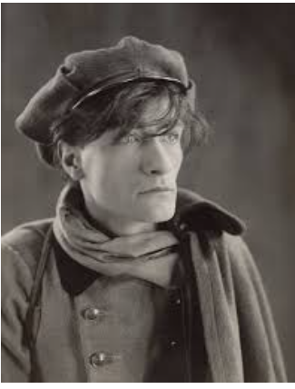

Antonin Artaud and the Theatre of Cruelty

Who Was Artaud?
Antonin Artaud was a French actor, writer, director and theatre theorist whose ideas challenged traditional Western theatre. Unlike Stanislavski, who aimed for psychological realism, Artaud wanted theatre to shock audiences and communicate through the senses.
His ideas became known as the Theatre of Cruelty. The word cruelty does not mean physical violence or deliberate harm. Instead, Artaud believed theatre should confront audiences with difficult truths and create an intense emotional and sensory experience.
Many modern experimental theatre companies have been influenced by his work, even though Artaud himself directed very few successful productions.

The Purpose of Theatre
Artaud believed that traditional theatre had become too dependent on written scripts and realistic dialogue. He argued that audiences often sat passively and simply watched events unfold.
He wanted theatre to:
- Affect the audience emotionally and physically.
- Break down the barrier between performers and spectators.
- Use movement, sound and imagery as powerfully as words.
- Explore dreams, fears and the subconscious.
- Reveal hidden truths about human existence.
For Artaud, theatre should be an experience rather than merely entertainment.

The Theatre of Cruelty
Artaud's most famous idea is the Theatre of Cruelty.
He described cruelty as:
A rigorous and disciplined assault upon the senses.
The purpose was to awaken audiences from everyday life and force them to confront emotions, fears and instincts that society often suppresses.
Cruelty could involve:
- Loud or unsettling sounds.
- Sudden changes in lighting.
- Disturbing images.
- Intense physical movement.
- Repetition and ritual.
- Non-naturalistic performance.
The goal was not to tell a realistic story but to create a powerful theatrical event.

Rejection of Naturalism
Artaud rejected realistic theatre because he believed it only reproduced everyday life.
He argued that:
- Realistic dialogue can limit meaning.
- Psychological realism ignores deeper emotions.
- Theatre should communicate through the body and senses.
Instead of realistic characters, performers may become symbols, forces or representations of emotions.

The Use of Gesture and Movement
For Artaud, the body was more important than spoken language.
Actors should use:
- Stylised movement.
- Gesture.
- Dance.
- Ritual actions.
- Physical expression.
Movement could communicate fear, anger, desire or suffering more directly than words.
The actor becomes a physical instrument capable of affecting the audience through energy and presence.

Audience and Performance Space
Traditional theatre often separates actors and audience through the proscenium arch stage.
Artaud wanted to remove this barrier.
He suggested:
- Audiences seated in the middle of the space.
- Performers moving around spectators.
- Action taking place on multiple levels.
- Unexpected entrances and exits.
The audience should feel involved rather than detached.

Ritual and Symbolism
Artaud was influenced by ritual, myth and non-Western performance traditions.
He believed symbols and images could communicate ideas more powerfully than realistic dialogue.
Examples include:
- Masks.
- Repeated gestures.
- Chants.
- Ceremonial movement.
- Symbolic props.
These elements create meanings that audiences experience emotionally rather than logically.

Task : Sensory Theatre
Take a short scene from a realistic play. (Maybe one you have studied/seen/found online)
Adapt it using Artaud's ideas by annotating/adding:
- Sound effect ideas..
- Repeated movements.
- Symbolic gestures.
- Lighting ideas.
- Non-naturalistic staging.
Summarise how this would change the meaning.

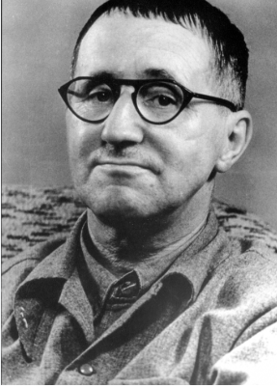

Bertolt Brecht and Epic Theatre

Who Was Brecht?
Bertolt Brecht was a German playwright, director and theatre practitioner whose work changed twentieth-century theatre. Unlike Stanislavski, who aimed for emotional truth, and Artaud, who sought a sensory experience, Brecht wanted audiences to think critically about what they were watching.
He developed Epic Theatre, a style of theatre designed to encourage social and political awareness. Brecht believed theatre should not simply entertain audiences or make them emotionally identify with characters. Instead, it should encourage spectators to question society and consider how change might be possible.
Many of Brecht's ideas emerged during periods of political instability in Germany and Europe. He believed theatre could be used as a tool for education and social criticism.

The Purpose of Theatre
Brecht argued that traditional theatre often encouraged audiences to become emotionally absorbed in the story. He believed this could prevent audiences from thinking critically.
He wanted theatre to:
- Encourage analysis rather than emotional involvement.
- Present social and political issues.
- Show that society can change.
- Make audiences question accepted ideas.
- Inspire people to think about their own world.
Brecht described theatre as a place for learning as well as entertainment.

Epic Theatre
Epic Theatre is designed to prevent audiences from becoming completely immersed in the story.
Rather than asking:
"What happens next?"
Brecht wanted audiences to ask:
"Why is this happening?"
"Could society be different?"
"Who benefits from this situation?"
The audience should remain aware that they are watching a performance so they can think critically about its ideas.

Verfremdungseffekt (Alienation Effect)
One of Brecht's most important ideas is the Verfremdungseffekt, often translated as the alienation effect or distancing effect.
The purpose is to prevent emotional identification with characters.
Techniques include:
- Actors speaking directly to the audience.
- Narration.
- Visible lighting equipment.
- Placards and projections.
- Songs.
- Scene titles.
- Actors stepping out of character.
These devices remind audiences that the events on stage are constructed and open to criticism.

Gestus
Brecht developed the idea of gestus.
Gestus is a clear physical action, gesture or attitude that reveals a character's social position, beliefs or relationships.
Examples might include:
- A wealthy employer refusing to make eye contact with workers.
- A politician shaking hands for appearances.
- A servant bowing excessively.

Gestus helps the audience understand social relationships rather than focusing solely on individual emotions

Narration and Episodic Structure
Brecht often organised plays into separate episodes rather than one continuous story.
Scenes may:
- Jump forward in time.
- Change location suddenly.
- Include narration.
- Reveal future events before they happen.
This structure encourages audiences to analyse each scene independently.
A narrator or projected title might tell the audience what will happen before a scene begins. Since suspense is reduced, the audience can focus on the reasons behind events.

The Actor in Brechtian Theatre
Brecht believed actors should demonstrate characters rather than become them completely.
Actors may:
- Comment on their characters.
- Show alternative choices.
- Step out of role.
- Address the audience directly.
- Reveal contradictions within the character.
An actor might show:
"This is how the character behaves."
rather than:
"I am the character."
This approach encourages audiences to judge the character's actions critically.

Design and Staging
Brecht wanted audiences to see the mechanics of theatre.
Features may include:
- Visible scene changes.
- Minimal scenery.
- Exposed lighting.
- Musicians on stage.
- Signs and projections.
- Functional rather than realistic sets.
The theatre should not create an illusion of reality.

Comparative Questions
- How does Brecht's view of the audience differ from Stanislavski's?
- Compare Brecht's alienation effect with Artaud's sensory theatre.
- Which practitioner gives the audience the most active role?
- How do the three practitioners use actors differently?
- Which practitioner's ideas are most relevant to contemporary theatre?

