Name:

**The transition from GCSE to A Level physics**

Welcome to A-level physics!

What you will be studying during your physics lessons at Sixth Form is no secret. We follow the AQA Physics specification; there is nothing to stop you from going to AQA website, looking at the Physics specification document and over the summer teaching yourself everything in the whole two-year course before you start in September! We have a few more realistic tasks for you, in order to prepare you for the transition from GCSE to A- level physics.

The tasks on the following pages are intended to give you practice at the sorts of skills that you need on the AS physics course, complete the tasks before the start of term and bring the completed booklet to your first AS Physics lesson.



Even more important are the suggestions in the final three pages called ‘become a better physicist’. If you have

anything that you think ought to be added to the lists, let me know. See you in September,

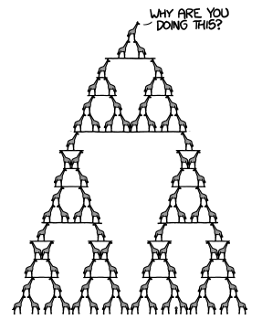

**Physics transition tasks**

**1. Dealing with symbols and SI units**

|  |  |  |
| --- | --- | --- |
| multiple | prefix | symbol |
| 1012 | tera- | T |
| 109 | giga- | G |
| 106 | mega- | M |
| 103 | kilo- | k |
| 10–3 | milli- | m |
| 10–6 | micro- | μ |
| 10–9 | nano- | n |
| 10–12 | pico- | p |

One of the highest jumps between GCSE and AS physics is the way things are written down. At AS level you’re expected to start using standard scientific notation.

Standard notation means:

• using the conventional symbols for quantities

• writing all quantities in terms of SI units (Système International)

• writing very large and very small numbers in standard form (e.g. 10–6

instead of 0.000001)

You will need to have memorised the unit prefixes shown in the table on the right – they are used in exams and it is assumed that you know what they mean.

Of course people in the real world don’t use standard scientific notation – you don’t see car speedometers with ms–1 scales on them or tyre pressure gauges calibrated in kNm–2. You’ll also encounter non-standard units in the physics course itself – megaparsecs, electronvolts and a.m.u. for example.

In the following ten pairs of quantities, circle the quantity which is greater.

a. 12 mW or 12 MW

b. 3.0 μs or 3.0 ns c. 27 kV or 27 GV d. 6 pm or 6 μm

e. 1024 TW or 1024 GW

f. 2210–2 Ω or 220 Ω

g. 300 kg or 3103 kg

h. 121 kN or 0.0121106 N

i. 3010–6 F or 0.003 pF

j. 14000 MHz or 1.4109 Hz

When you write out the name of a unit in full it is always written completely in lower case letters. For example: the unit of power is the watt (symbol W). In the box above, next to each question write the full name of the SI unit in the question. Bonus points if you find out why some symbols are written using upper case (e.g. N) whereas other unit symbols are written using lower case (e.g. s).

You must bring a working scientific calculator to all of your physics lessons and exams. Your calculator has a button that says ENG . Find out what this button does, and why it will be useful to you on your physics course. Describe the function and usefulness in the space below.

**2. Dealing with vector quantities**

You should already know that a quantity like speed only has a size (e.g. 13 ms–1), but there is another type of quantity (called a vector) that has a size and direction, e.g. a velocity of 13 ms–1 *to the left*. You can represent velocities with arrows – the longer the arrow the greater the size (speed) of the velocity.

At AS level you will become proficient at working in more than one dimension, and in order to do this you will need to master vectors. For example, the formula for working out the change in velocity looks simple enough:

**change in velocity (ms–1) = final velocity (ms–1) – initial velocity (ms–1)**

However, you can’t just subtract one speed from the other – you have to account for the directions of the two velocities.

Example: find the magnitude (size) of the change in velocity if you have an initial velocity of 5 ms–1 to the right and a final velocity of 3 ms–1 downwards.

3 ms–1

–



5 ms–1

3 ms–1



= +

5 ms–1

Δv is the change in velocity.

=



You find Δv by reversing the arrow for

the intial velocity and adding this new arrow to the final velocity.

Δv

5 ms–1



3 ms–1

Either by measuring from a scale drawing, or by using Pythagoras’ theorem, the answer is **Δv = 5.8 ms–1**.

Have a go at finding the changes in velocity in these two cases:

a. initial velocity = 4 ms–1 upwards;



final velocity = 4 ms–1 to the right

b. initial velocity = 3 ms–1 down;

final velocity = 4 ms–1 to the left.

**3. Dealing with equations**

Forces stretch things, squash things and twist things. When we consider things as whole objects (“bodies” in physics language) then Newton’s Second Law of Motion deals with the way that forces make bodies go faster, slower or change direction. The resultant force acting on a body makes it accelerate, and the size of the acceleration is directly proportional to the size of the force.

**resultant force (N) = mass of body (kg)**  **acceleration (ms–2)**

or, in symbols

**F = m a**

Example: A car of mass 1000 kg accelerates uniformly from rest at a rate of 0.75 ms–2. What is the size of the resultant force accelerating it?

Solution: F = m a = 1000 kg  0.75 ms–2 = 750 N Answer the following in the spaces provided:

a. A bus of mass 10000 kg accelerates at 0.25 ms–2. What is the resultant force acting on it?

b. A car pulls a caravan of mass 800 kg. If it accelerates at 0.4 ms–2, what force must the caravan experience?

Example: What would the acceleration of a 0.5 kg body be if a force of 10 N acted on it? Solution: F = ma. Dividing both sides by m gives F/m = a, so a=F / m = 10 N /0.5 kg = 20 ms–2.

Answer the following in the spaces provided:

a. What would be the initial acceleration of an arrow of mass 0.3 kg shot from a bow if the force from the bow-string is 200 N?

b. What would be the acceleration of a train of mass 104 kg if the force form the engine is 8kN?

Example: What is the mass of a body if a force of 250 N produces an acceleration of 2 ms–2? Solution: F = ma. Dividing both sides by a gives F/a = m, so m = F/a = 250 N / 2 ms–2 = 125 kg

Answer the following in the spaces provided:

a. What is the mass of a sailing boat if a force of 120 N produces an acceleration of 0.5 ms–2?

b. What is the mass of an electron if a force of 1.810–14 N produces an acceleration of 2.01016 ms–2?

So, you have chosen to study physics at college. Since you’re not being forced to do it I’m going to

assume that you want to be a better physicist. Here are suggestions for things that you should do to

**become a better physicist**

**1 Read books**

It will help to stand back and see physics in its wider context, and also to look in more detail at some areas of physics that you may currently know very little about. I consider reading the two books in bold below to be the easiest way for you to do this, and they’re something that would be easy to obtain and simple for you to take away with you on holiday. Both books are written at a level that assumes very little about your prior subject knowledge, but reading them will stretch you into areas that go beyond university level. The other books are also highly recommended.

• ***A Short History of Nearly Everything* by Bill Bryson**

• ***Big Bang: The Most Important Scientific Discovery of All Time and Why You Need to Know***

***About It* by Simon Singh**

• *A Brief History of Time* by Stephen Hawking

• *The Universe in a Nutshell* by Stephen Hawking

• *The Making of the Atomic Bomb* by Richard Rhodes

• *Carrying the Fire: An Astronaut’s Journeys* by Michael Collins (the Apollo 11 astronaut).

• *13 Things That Don’t Make Sense: The Most Intriguing Scientific Mysteries of Our Time* by

Michael Brooks

• *Surely you’re joking Mr Feynman* by Richard P Feynman and Ralph Leighton.

• *Six Easy Pieces: Fundamentals of Physics Explained* by Richard P Feynman (or any other book by the same author)

**2 Watch online video**

• Watch any or all of the “Schools Lecture series” videos made by the Institute of Physics. Don’t be put off by the title – they are all presented by experts in physics at the right kind of level, and the topics covered will really help you understand some of the details of the A level course. The link is: <http://www.iop.org/resources/videos/education/>

• You could spend your whole life watching physics video clips on youtube. No need, however, as

the **minutephysics** is all you’ll ever really need – and all clips are only a minute long. Subscribe. Watch them all. <http://www.youtube.com/user/minutephysics>

• Richard Feynman’s “**Messenger Lectures**” on physics, archived with transcripts on Microsoft’s

Project Tuva website. <http://research.microsoft.com/apps/tools/tuva/>

**3 Watch television programmes**

Channels on Freeview to keep an eye on are BBC2, BBC4, Quest and Dave. Specific programmes to look out for, in order of personal preference, are:

• **Mythbusters** (on Quest, but also on cable and satellite channels) – Arguably the best show about scientific investigation, with added rockets! Watch it.

• **The Sky at Night** (BBC4) – longest running science TV programme in the universe, everything

current in space and astronomy with proper experts.

• **Horizon** (BBC2 and BBC4) – topical science documentary, often physics-based. A bit wooly sometimes, but there have been interesting ones about neutrinos, time, black holes, etc.

**4 Listen to audio**

Mainly BBC Radio 4 broadcasts / iplayer / podcasts. Usually archived so they don’t expire! These are in

order, starting with the most relevant...

• **In Our Time** - Melvyn Bragg and guests discuss the history of ideas. My favourite, usually four professors having a sensible discussion, frequently on physics topics. Vast archive going back years, and more being added all the time. Examples of relevant episodes: The Age of the Universe, Radiation, The Vacuum of Space, The Measurement Problem in Physics, The Multiverse, Gravitational Waves, The Speed of Light...

• **The Life Scientific** - Professor Jim Al-Khalili talks to leading scientists about their life and work,

finding out what inspires and motivates them and asking what their discoveries might do for mankind. Many episodes available on iplayer.

• **Frontiers** - Programme exploring new ideas in science and meeting the scientists and researchers responsible for them, as well as hearing from their critics. Dozens of episodes available on

iplayer.

**5 Use your computer to do some physics**

• [**SETI@home**](mailto:SETI@home)is a scientific experiment that uses Internet-connected computers in the Search for Extraterrestrial Intelligence (SETI). You can participate by running a free program that downloads and analyzes radio telescope data. <http://setiathome.berkeley.edu/>

• **Asteroid watch.** Search for Near Earth Objects (i.e. asteroids) in observations that have taken, and report back their positions.

<http://www.schoolsobservatory.org.uk/activ/asteroidwatch>

• **Galaxy zoo.** To understand how galaxies, and our own, formed we need your help to classify them according to their shapes — a task at which your brain is better than even the most advanced computer. If you're quick, you may even be the first person in history to see each of

the galaxies you're asked to classify. <http://www.galaxyzoo.org/>

• **Zooniverse**. Many other projects similar to galaxy zoo: solar stormwatch, planet hunters, the

Milky Way project. <https://www.zooniverse.org/>

• **PhET interactive simulations**. Fun, interactive, research-based simulations of physical phenomena from the PhET project at the University of Colorado. This site will be used again and again during your A level course. <http://phet.colorado.edu/>

**6 Follow physicists on twitter**

• **Brian Cox** [(@ProfBrianCox)](mailto:@ProfBrianCox)

• **Jim Al-Khalili** [(@jimalkhalili)](mailto:@jimalkhalili)

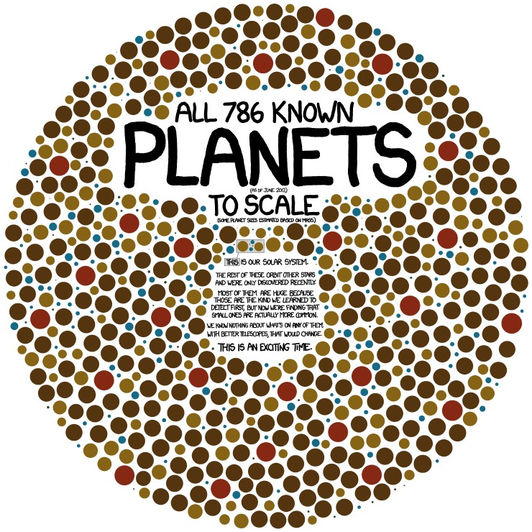

• **Andy Newsam** [(@AstroAndyN)](mailto:@AstroAndyN)

• ***Michio Kaku*** [(@michiokaku](mailto:@michiokaku))

**7 Read magazines**

• **New Scientist** is the big one.

**8 Laugh at comedy**

The best original online physics-related cartoons are at **xkcd.com** (example on the right). Also features love, math and sarcasm.

Also witness the stand-up comedy of

• Dara O’Briain

• Tim Minchin

• Robin Ince

**Disclaimer**: I accept responsibility for none of the above. You should be taking responsibility for your own development as a

physicist. If you don’t do any of the above then you’re not likely to get very much out of A level physics – be proactive!