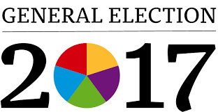
A Level Politics – summer task

This task is designed to help you directly with your knowledge and understanding of the General Election of 2017. This will be one of the elections we will study and analyse as part of our course so any background research you can do will help you prepare for the new A Level course.
1.Why do you think Theresa May called the general election?
(Hint – find out about the opinion polls in 2017 and the issues she has been dealing with)
2. Using data from the bbc website and a polling website such as YouGov, find out how people voted on the basis of the following factors:
Age
Class (do not worry if you struggle to identify this category)
Gender
Income
Region
Ethnicity

3.What do you think was the most important factor in explaining how people voted?

- Which policies were popular with voters? (You can look at summaries of the policies online by looking up about the party manifestoes)

- Which policies were unpopular with voters?

- Why do you think the Conservative Party failed to get an increased majority?

- Why did the vote for Labour increase so significantly from 2015?

- Why has the result of this election caused so many problems for Theresa May?

Bring your research to the first lesson in September and you can include graphs and other data too.

