The Making of Modern Britain 1951-2007.
Read the sources and then answer the questions that follow
Politics:
What was life like in Britain in 1951?
Sir Winston Churchill  Born. 30 November 1874, Blenheim Palace, Oxfordshire. Died. 24 January 1965, London. | Conservative Prime Minister x2:  1940 to 1945:  1951 to 1955 | By his re-election in 1951, Churchill was “gloriously unfit for office”, addicted to painkillers and alcohol
His second term was most notable for the Conservative Party’s acceptance of Labour’s newly created Welfare State. | 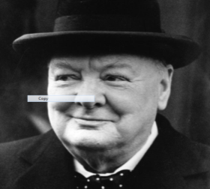 | Ageing and increasingly unwell, he often conducted business from his bedside, by 1951 the Prime Minister’s leadership was less decisive than during the war.
Churchill was viewed as a flamboyant larger than life character however he was more comfortable and better skilled as a world statesman than domestic politician. | He became known as the ‘absentee PM’. Day to day government was left to Anthony Eden (for sec) and Rab Butler (Chan of Exchequer). | A stoke in 1953 further limited Churchill’s political impact. He was an invalid and his speech seriously affected by the stroke

Churchill’s re-election in 1951 marked the end of the post war Labour Government which had introduced massive social reforms known as the Welfare State. Even though the Conservatives were to dominate politics for the next 13 years the previous Labour government set the tone. The Conservative Party dominated as they were viewed as the ‘Natural party of Government’ and the policy makers at the time were keen to build on Labour’s ideas of social co-operation and justice.
Labour almost won re-election in 1951, it received the largest proportion of votes it ever received 48.8% compared to Conservative 48%; however the conservative received more seats in the House of Commons: 321 compared to Labours 295

Economics:
What was life like in Britain in 1951?
Men’s average weekly wages were set to increase: from £8.30 in 1951 to £15.35 in 1961 | Car and house ownership increased | Private savings increase
Labour’s planned ‘new towns’ such as Stevenage and Corby were rapidly expanding to provide housing for the growing population and replace Victorian slum dwellings | Food rationing being scaled down every year to end completely 1954 | Consumer items such as the TV and the washing machine were widely available

In 1951 the British people were better dressed, better fed and had more leisure opportunities than ever before. The ‘affluent society’ was arriving in the form of cars, washing machines and TVs. One political commentator said of people in Wigan had gone…..:
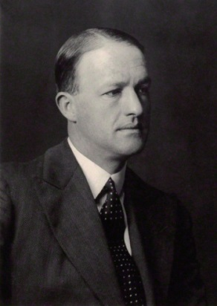
“……from barefoot malnutrition to nylon and television” …..by the 1950s
R.A Butler- ‘The best PM the Conservatives never had’ played a key role in reorganising the party after the second world war and in preparing for power in 1951. He was Chancellor of the Exchequer between 1951 and 1955, a period which oversaw the beginnings of extensive economic recovery and growth.
People felt richer than ever before with an increase in men’s weekly wages and savings of £134m in tax cuts.
However this growth was also accompanied by decline:
Britain was in massive debt to the USA due to the war and huge economic challenges were posed by continued military spending
Industry needed investment to modernise and improve productivity and competitiveness
We had lost markets during the war and our staple industries such as coal and steel were in decline compared to the rest of the world
The UK was sliding down the economic league tables compared to USA, Japan and Europe

Society:
What was life like in Britain in 1951?
Entertainment:
Life in 1951 was very different from today but not unrecognisable.
TVs were in some homes but all were black and white
No mass entertainment people went to the cinema or listened to the radio or went to church, Sunday was a day of rest as factories open on a Sat morning
No such thing as youth culture
No supermarkets and rationing and shortages from the war still felt up to 1954
Travel: No motorways
Few cars but ownership was growing
Much less air travel, most did not have a passport: working class holiday camps such as ‘Butlins’ were started
Most people got to walk on trains, trams or walked
Class and Gender: Little social mobility
All children given free education up to the age of 14
Class divisions strong and determined voting behaviour
Political establishment were privately educated at Eton/Harrow then attended Oxford/Cambridge
Property owning middle classes lived in suburbs liked gardening, voted conservative and were beginning to owe cars
Working class urban areas were loyal to trade unions and voted Labour
The start of the ‘teenager’: Teddy boy sub culture influenced by USA
North/south divide: northern areas industrial
Very few married women worked

What was life like in Britain in 1951?
International: Britain’s place in the world

By 1951 Britain had to face up to the prospect of imperial decline | The British empire once consisted of countries such as –  Australia, New Zealand, Canada, India, Kenya, Rhodesia | Decline in Britain’s power had begun after WW1 but WW2 left it badly damaged, burdened with massive debts
Britain tried to keep pace with the two super powers the USA and USSR by developing their own nuclear weapons | 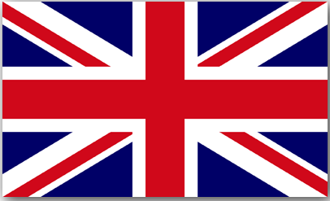 | Immigration from Commonwealth countries made Britain more multi-cultural
In the early 50’s Britain’s rulers believed they could transition from Empire to Commonwealth | In 1947 Britain also granted independence to India and Pakistan, marking Britain’s ‘retreat from empire’ | Britain was fighting against the pressure of colonial independence movements. These were hard to contain

The British Empire covered one quarter of the earth’s surface and governed a similar proportion of the world’s population. Yet between 1947 and 1964, Britain granted independence to most of its colonies
The people of the ex-colonies were allowed British passports as Commonwealth citizens. Some of these people chose to make a new life for themselves in Britain. This immigration from ex-colonies was encouraged by post war governments due to the shortages of workers in Britain particularly in the NHS.
Churchill was keen that Britain kept a high profile internationally. His government ensured we were the 3rd power to test and own Nuclear weapons. He also worked to ensure Britain’s place on the security council of the newly established NATO.

What was life like in Britain in 1951?
Politics  Describe:  What type of Prime Minister was Churchill in 1951-55?  Explain:  How did follow Labour’s policies ‘set the tone’ for Conservative governments?  Analyse:  What conclusions can you draw about the strengths and weaknesses of Churchill and the Conservative government in 1951? | Economics  Describe:  Who was Rab Butler and what did he do?  Explain:  Why were the 1950’s known as the ‘age of affluence’?  Analyse:  Is it true say in 1951 Britain was entering a period of economic growth and prosperity?
Society  Describe:  What words summarise society in 1951?  Explain:  How was life different from today?  Analyse:  To what extent were social divisions evident in society in 1951? | Britain’s place in the world  Describe:  What was the state of Britain’s Empire in 1951?  Explain:  How did the process of decolonization and creation of the Commonwealth effect Britain?  Analyse:  To what extent was GB declining as a global power?

Key images from 1951
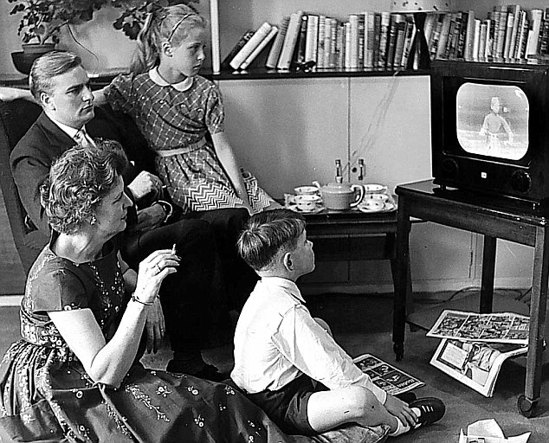 | 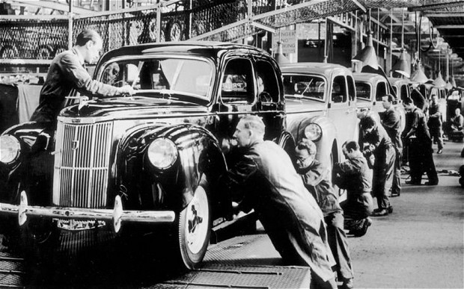
What clues does this picture reveal about life in 1951? | What clues does this picture reveal about life in 1951?
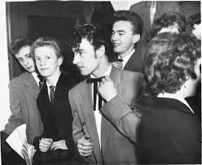 | 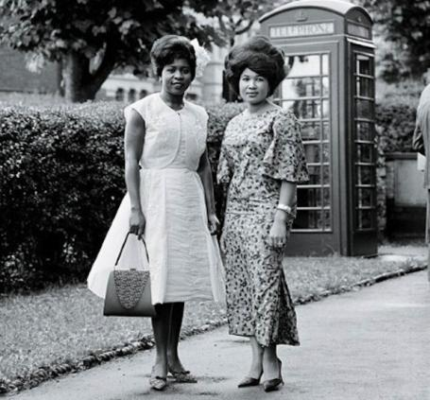
What clues does this picture reveal about life in 1951? | What clues does this picture reveal about life in 1951?
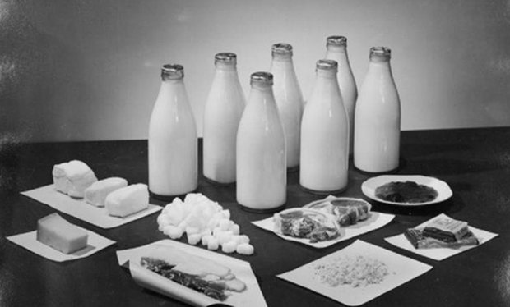 | 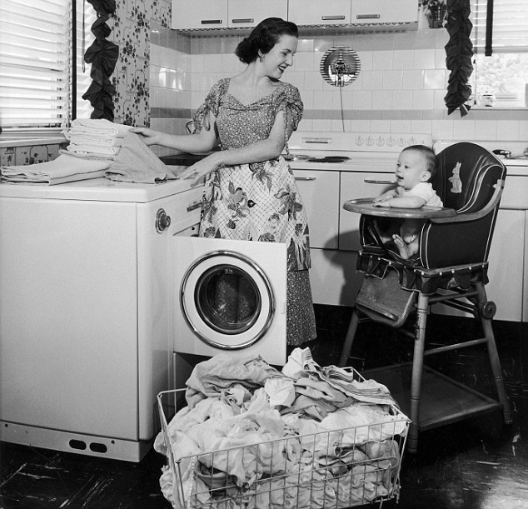
What clues does this picture reveal about life in 1951? | What clues does this picture reveal about life in 1951?

