J6th News & Events 2
October 2016

STUDENT DECLARATION FORMS
Year 12- You are doing great! Most of you have returned your forms (If you haven’t, please do so),
Year 13- There are still a lot of forms missing- please hand them in as a matter of urgency!

YEAR 6 OPEN EVENINGS
Thank you to those of you who volunteered for the Year 6 Open Evenings. Both events were a huge success!

J6TH OPEN EVENING- VOLUNTEERS NEEDED
On October 13th 2016, Beverley High School will be hosting our Year 12 open evening for students interested in joining us next year. WE NEED YOUR HELP! We strongly believe that our students are the best at informing prospective students of what life in the 6th form is really like. Please let Miss Gardiner know if you are interested in signing up to be a J6th student ambassador for the evening (it also looks really good on a CV or personal statement!).

CAREERS FAYRE
This year, Beverley Grammar School will be hosting a careers fayre, inviting people from a variety of companies and post A-level providers. Year 12 & 13 will be taken off timetable to go to the event at 10:35 on Wednesday 19th October 2016.

ALLERTHORPE ACTIVITY DAY
40 of of Year 12 students enjoyed an action packed activity day at Allerthorpe lake at the start of October. They showed great teamwork, leadership skills & intuition (although some struggled to keep the boat the right way up!).

THE WEDNESDAY AFTERNOON SPORT CHALLENGE
Come along to the Sports Hall at BHS on a Wednesday period 4 and 5 for a chance to enjoy playing sport with other 6th formers and to discover new sports.

LONDON TRIP - NOVEMBER 2016
30 students and 4 staff will be heading to London for the weekend at the end of November. The provisional itinerary has been sent around. Please make sure you feedback any suggestions for other places you would like to visit to Miss Gardiner as soon as possible.

HE+
HE+ is a programme designed to provide our academically driven students with extra support, evenings, lectures & trip opportunities aimed at getting them into top Universities. Students must register their interest with Mrs Field by Friday 14th October!

MEDICAL SOCIETY
The HYMS 3-day medical experience has been advertised. If you have not signed up yet please contact Mrs Field for an application form.
Nottingham University are advertising a two day intensive workshop for would be doctors. Follow the link if you are interested to find out more: http://www.workshop-store.co.uk/Medlink-Dec-17th-18th-2016

YEAR 13 LEAVERS HOODIES
Thanks to Greg and Ryan in Year 13, the online shop is now open for the class of 2017 to order your J6th leavers hoodies. Please refer to your email, follow the link and purchase your hoodie! The shop will close on November 10th.

YOUNG MUSICIAN OF THE YEAR
This annual event is open to all Beverley Grammar School and J6th students. Whether you play classical, modern, sing or drum, we want to hear your talent! The overall winner will receive the ‘Young Musician’ shield and a cash prize. Closing date for entries: Wednesday 19th October 2016

LIFE SKILLS FOR UNIVERSITY
Year 13 have been learning all about cooking and finance in preparation for leaving home. Parents- call on your son or daughter to make a meal for the family to ensure they are ready for independent living.

SCHOOL GOVERNORS
Our School Governors are interested in what you have to say. Whether it is to let them know what you love about the J6th, or areas for improvement, they want to hear your voice. Speak to someone on the J6th team about how to contact them.

NATIONAL CITIZEN SERVICE
Year 12 have had a fantastic presentation from NCS. They are offering our students the opportunity to improve their CV, make a difference to the local community & have an amazing time (activities include outdoor residential, 1st Aid course, leadership course, UCAS guidance, social action project & graduation ceremony). The trip is subsidised so will only cost you a maximum of £50, instead of £1400. It starts on 21st October 2016 so sign up today!

DO AS GRADES MATTER?
YES! We have heard rumours going round about your performance at AS not impacting on you, leaving some people feeling rather laid back. Please be aware that your performance at AS level can impact on your choices for Year 13 (You can not continue a subject with a U grade and you must have 3 subjects to continue into year 13) as well as your choices for University or Higher Apprenticeship (Your predicted grades will be lower.)!

6th FORM CHARITY
Our Year 13s have selected Teenage Cancer Trust as their charity of the year. We look forward to seeing what fundraisers you get up to!

REGISTER TO VOTE!
From 16 years old, individuals can register to vote. Visit https://www.gov.uk/register-to-vote it’s really easy and only takes 5 minutes. Remember to have your national insurance number and passport to hand. Failure to register when you are requested to do so by the local council or other government body can result in an £80 fine!

PROM UPDATE
Our fantastic Head Boy & Girl team have done their research, visited venues and booked Lazaats as their venue for 4th July. The decorations, food, fundraising and after-prom committees are all working hard to make it a spectacular evening.

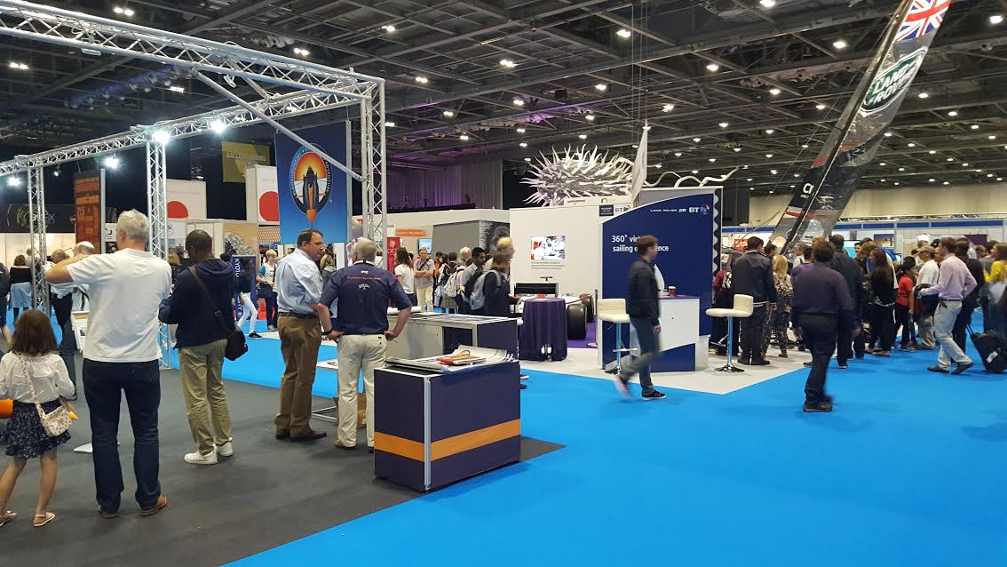
New Scientist Live- a report from 3 of our Year 13 students!
‘A few weeks ago, the ExCel in London hosted New Scientist Live - a collection of new technology and innovative science, which ranged from emotion robotics to marine exploration. With talks from experts, I enjoyed listening to Andrew Steele's talk on Superconductivity in the Cosmos Theatre. Phil liked the evolutionary Biology discussions, and Isaac experienced VR for the first time! Alfi.’

KEY DATES FOR YOUR DIARIES

Thursday 13th October- J6th open evening- volunteers needed!
Friday 14th October- Deadline for HE+ applications
Wednesday 19th October, p2- Careers Fayre at BGS
Wednesday 19th October- Deadline for registering for Young Musician of the Year
Friday 21st October- NCS Begins
Thursday 10th November, 7pm- Young Musician of the Year Competition
Thursday 10th November- J6 ‘class of 2017’ Hoodie online shop closes
Tuesday 14th February- Year 12 parents’ evening
Wednesday 1st March- Year 13 parents’ evening
Tuesday 4th July- Prom

