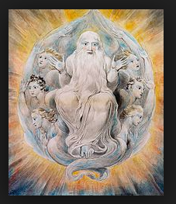

**2. What is God like?**

Watch the video and make notes on the traditional ideas about the nature of God and the problems with these ideas.

<https://www.youtube.com/watch?v=gs_gY1K1AMU&list=PL8dPuuaLjXtNgK6MZucdYldNkMybYIHKR&index=13>

**1. Religious Experience:**

Watch the video, found on the link below. Make notes on what religious experience is and the examples mentioned on the video.

<https://www.youtube.com/watch?v=uj-qvJLI-Ck>

**A Level RS YR 12- Summer Research. (BHS)**



**3. The Problem of Evil:**

Watch the video (link below) and explain what the ‘Problem of Evil’ is. What is a theodicy and which is the most popular theodicy? What is the main problem for this theodicy?

<https://www.youtube.com/watch?v=9AzNEG1GB-k&list=PL8dPuuaLjXtNgK6MZucdYldNkMybYIHKR&index=14>



**4. St. Thomas Aquinas:**

Watch the video and explain…

Who was Aquinas?

What are his main ‘Five Arguments’ for the existence of God?

<https://www.youtube.com/watch?v=Mz_iGGGMddw>

**5. Reasons to believe in God:**

Watch the video and make notes on reasons why people believe in God. Focus mostly on religious experiences.

<https://www.youtube.com/watch?v=uNmrIM4Dl3U>



**6. Religious Experiences:**

Research the religious experiences of either Nicky Cruz; Joseph Smith or Yusaf Islam.

Find out about the nature of the experience, what happened and the effect it had.

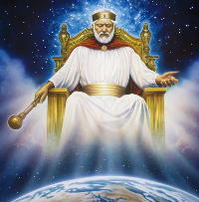



**7. Read Sophie’s World, Jostein Gaarder:**

This is a great fictional novel that is a nice easy read and a really good introduction to the history and development of philosophy. Don’t get it mixed up with Sophie’s Choice which is a harrowing true story during the Holocaust.

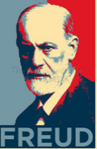

**8. Freud on religion:**

What did Freud think of religion? Why does he say there is a link between religion and obsessive actions? What does he say about the reasons for why people follow a religion? How did Freud shape thought about religion?

<https://www.youtube.com/watch?v=1U440mcsebE>

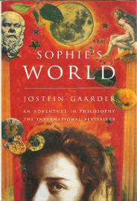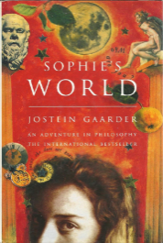

**10. Plato – the Allegory of the Cave:**

What is the purpose of philosophy? What is the meaning of the Allegory of the Cave? How does the philosophical process work? Why is this process important (according to Plato)?

<https://www.youtube.com/watch?v=SWlUKJIMge4>

**9. ‘Religion is the opium of the people’:**

Why did Karl Marx say this? How has this been misunderstood? What else does Marx say about religion?

<https://www.youtube.com/watch?v=bHxiMNvdWdA>

