Media Studies
At A Level, you’ll be analysing products from a wide range of media forms. Get started on exploring these different forms by enjoying some of the shows, lectures or documentaries from the selection below.
General
BBC R4’s The Media Show
Weekly topical radio programme about the fast-changing media world.
Online, Social and Participatory Media
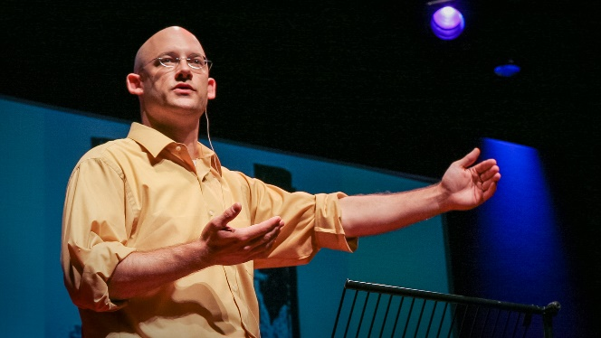
TED Talks: Clay Shirkey, Social Media Theorist
Clay Shirky argues that the history of the modern world could be rendered as the history of ways of arguing, where changes in media change what sort of arguments are possible — with deep social and political implications.
How social media can make history
How the Internet will (one day) transform government
Film and Television
Mark Kermode’s Secrets of Cinema (Series 2, BBC iPlayer)
Film critic Mark Kermode reveals the film-making tricks and techniques behind classic movie genres, from romcoms to horrors.
Great for understanding genre codes and conventions.
Available episodes here.

Video Gaming
BBC Horizon: Are Video Games Really That Bad?
The video game industry is a global phenomenon. There are over 1.2 billion gamers across the planet, with sales projected soon to pass $100 billion per year. But their very popularity fuels the controversy that surrounds them. They frequently stand accused of corrupting the young - of causing violence and addiction. But is this true?

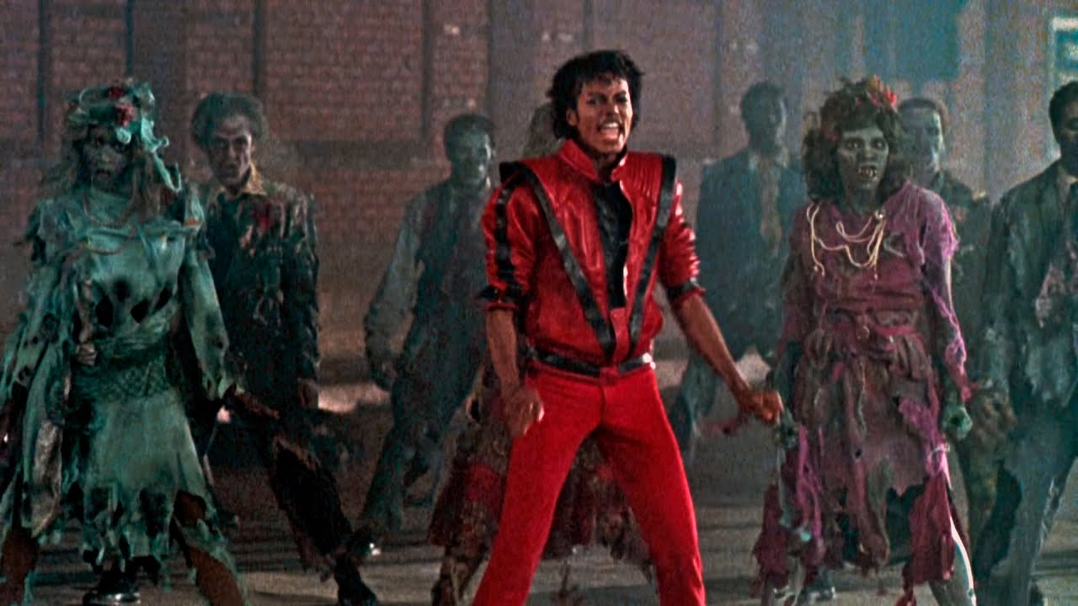
Music Videos
indie88.com article: 11 music videos that changed the game
Documentary: Making Michael’s Jackson’s Thriller
Michael Jackson’s 1983 Thriller remains the most popular music video of all time: a 14-minute horror spoof that changed the business. This behind-the-scenes documentary chronicles the taping of Thriller and includes additional behind the scenes footage and interviews to tell the story. From dance rehearsals and choreography, to wardrobe, to the makeup and transformation of Michael from man to werewolf!
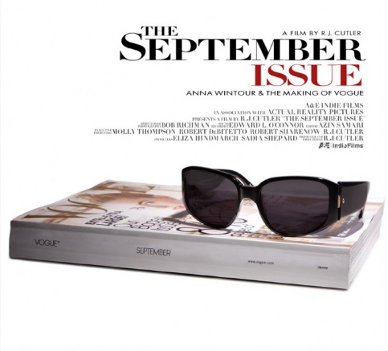
Print Magazines
The September Issue: Anna Wintour and the Making of Vogue
Anna Wintour, the legendary editor-in-chief of Vogue magazine for twenty years, is the most powerful and polarizing figure in fashion. Hidden behind her trademark bob and sunglasses, she has never allowed anyone to scrutinize the inner workings of her magazine. Until now. With unprecedented access, filmmaker R.J. Cutler’s new film THE SEPTEMBER ISSUE does for fashion what he did for politics in THE WAR ROOM, taking the viewer inside a world they only think they know.
Documentary available to rent or buy on Amazon Prime.
Watch the trailer here.
Newspapers
The Papers (BBC iPlayer)
No need to wait until tomorrow morning to see what's in the papers – watch a lively and informed conversation about the next day's headlines.
This is good for comparing how papers across the political spectrum cover the same news stories in different ways – e.g. front pages.
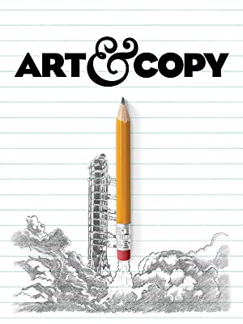
Advertising and Marketing
Documentary: Art and Copy
A non-stop barrage of great work, incredible stories, and insights into the creative process in advertising. Directed by Doug Pray, it's a labour of love that shows a passion for the production of good advertising, and features some of the most famous campaigns ever produced.

Radio
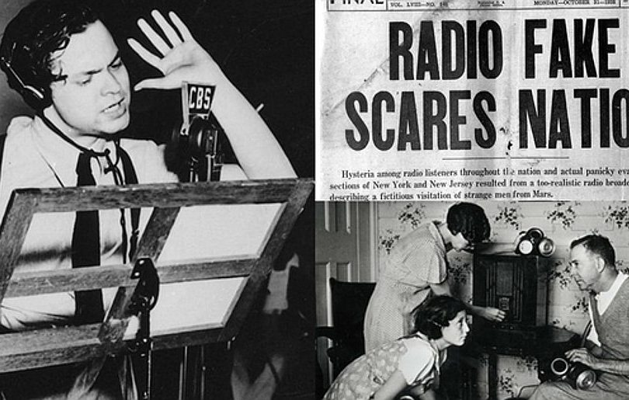
BBC R4: Orson Welles and The War of the Worlds – Myth or Legend?
Christopher Frayling explores the most notorious hoax in radio, broadcast in 1938 - Orson Welles' production of H G Wells' The War Of The Worlds. The drama, disguised as a dance music programme punctuated by a series of fake news broadcasts telling of a Martian invasion, played out at a time when the USA was in the grip of pre-WW2 invasion anxiety, fearing that Nazi Germany would make an attack on mainland America. Public reaction was seemingly extreme with widespread panic and isolated groups of people fleeing their homes. The event was reported all over the world and has become part of broadcasting legend. But just how real was the panic?

